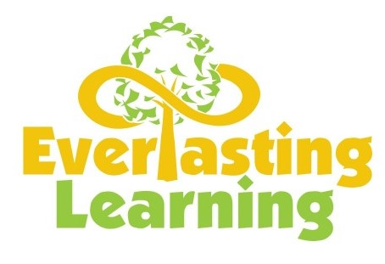

Toddlers A & B
6:00 – 7:00 Meet & Greet
7:00 – 8:00 Breakfast / Child Directed Activities
8:00 – 8:15 Potty Time / Wash Hands
8:15 – 8:30 Every Day Counts / Math
8:30 – 8:45 Whole Group / Reading & Writing Instruction
8:45 – 9:30 Outdoor Play
9:30 – 9:45 Potty Time / Wash Hands
9:45 – 10:00 Snack / Wash Hands
10:00 – 10:30 Small Group Instruction
10:30 – 11:00 Curriculum Lesson
11:00 – 11:30 Potty Time / Wash Hands
11:30 – 12:00 Lunch
12:00 – 12:15 Potty Time / Wash Hands
12:15 – 12:30 Story Time
12:30 – 2:00 Rest Time
2:00 – 2:15 Potty Time / Wash Hands
2:15 – 2:30 Science / Social Studies
2:30 – 2:45 Spanish
2:45 – 3:00 Snack / Wash Hands
3:00 – 3:30 Art Activities
3:30 – 3:45 Potty Time / Wash Hands
3:45 – 4:30 Review Lesson
4:30 – 5:00 Music & Movement
5:00 – 6:00 Indoor Play

